Homepage URL: <https://automaton.crosscode.in/>

Click on “Apply Now” button to access enquiry form

Admin URL: <https://automaton.crosscode.in/login>

Login credential: admin/admin

Agent URL to access Enquiries: <https://automaton.crosscode.in/login>

Login credential: agent/agent

Please find Developer comments inlined below.

**UAT Feedback on Automaton**

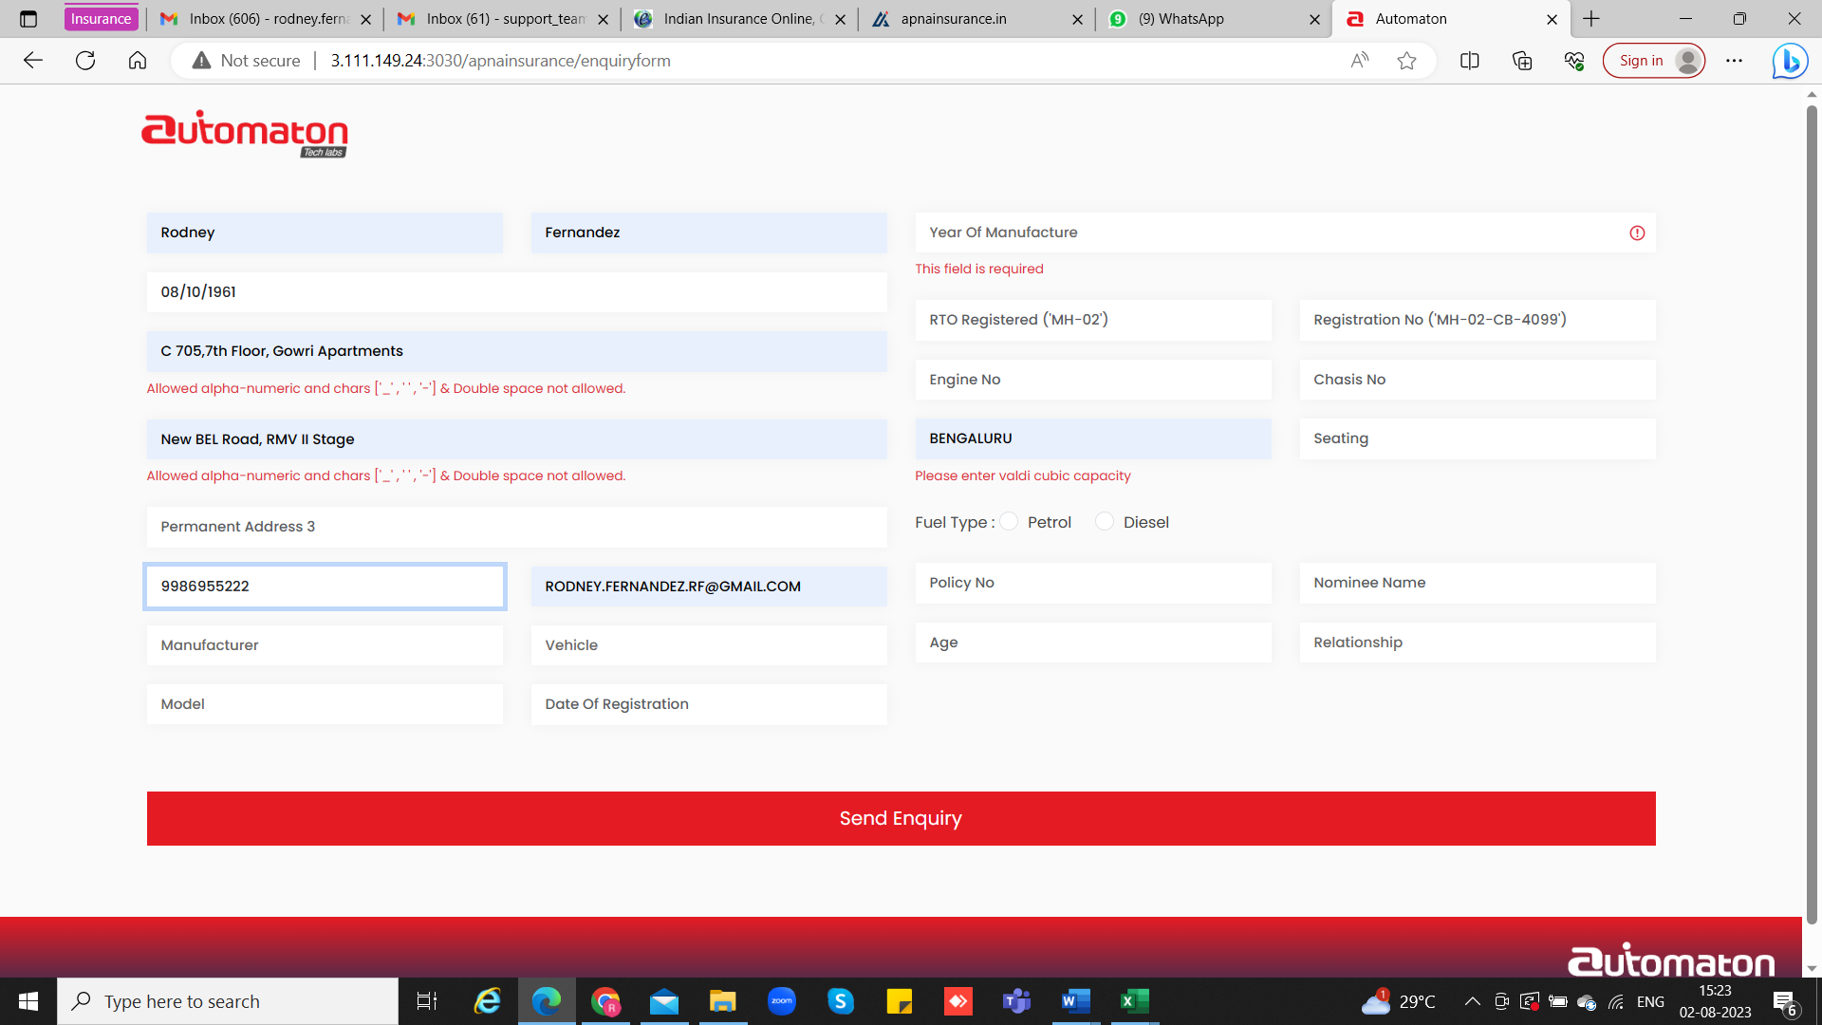

See screenshot above:

1. The structure of the data collection page should be in place as below – currently the page has data fields mixed up, which can be confusing for the customer…
   1. Personal Details
   2. Vehicle details
   3. Current Insurance Policy Details
   4. Nominee Details

Dev Comment: We have divided the input fields under enquiry form into Four groups as above.

Access the URL: https://automaton.crosscode.in/enquiryform

1. It will be good if we have the data entry process as a Question/Answer session….we can include statements like below:
   1. Personal Details **– Good day, kindly enter your Personal Details for this Application**
   2. Vehicle details – **Now you’ll be required to share the Vehicle details**
   3. Current Insurance Policy Details – **Please share the existing Insurance policy information for a seamless transfer**
   4. Nominee Details – **Finally your Nominee Details which will help us process this application**

Dev Comment: Done

1. Can we have all the Field Names appearing above the actual field for entering the data…it will help the customer/dealer in filling this information

Dev Comment: Done

1. In the Permanent Address 1, 2 & 3 fields, special characters are not allowed…most addresses will have a “,” (comma) atleast – it also states that alpha number characters are not allowed – in the address field, there will be alpha number characters

Dev Comment: Done

1. While the Manufacturer is a drop down, I am unable to enter any Vehicle details, I am assuming that this will also be a drop down of the respective manufacturer vehicles…kindly confirm…

Dev Comment: Yes, you are correct, Vehicle input is a drop-down, that is being managed by Admin. Admin has option to add vehicles under each Manufacturer. Currently only configured for manufacturer “Aston Martin”. You may select the same “Aston Martin” to load vehicle dropdown to verify. Admin screen below for your reference. Login as admin and configure.

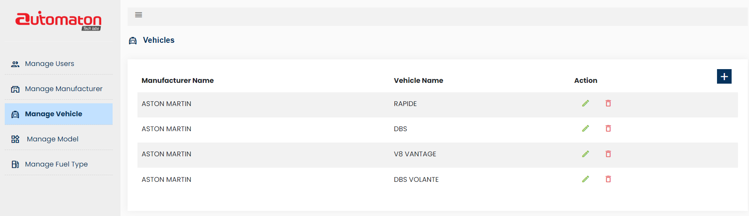

1. Field Name of “Vehicle” to be renamed as “Variant” – I am assuming this will also be a drop down based on the excel data provided…

Dev Comment: Done

1. Date of Registration cannot be more than 15 years prior to the proposal date, we can build that validation.

Dev Comment: Done (It won’t allow to select date before 15years from Today in the calendar)

1. The radio buttons for “Petrol / Diesel” are not visible clearly, maybe they can be in a difference colour

Dev Comment: Done

1. The field “Policy No” to be revised to “Insurance Policy Number”

Dev Comment: Done

1. We will need to Include the “Existing Insurance Company” as one of the datafields for capturing, so that we know with whom we need to coordinate for the transfer…

Dev Comment: Done

1. The fields for the nominee “Age” and Relationship” to be revised to “Nominee’s Age” and “Relationship with the Insured”

Dev Comment: Done

1. So based on these details above, I am currently unable to submit an enquiry, so am unable to see what happens next…kindly share the format in which the information will be shared through the application to the Apna Team…or can we have pre defined

Dev Comment: Login as an agent using mentioned url and credentials on top to view the Enquiry details.